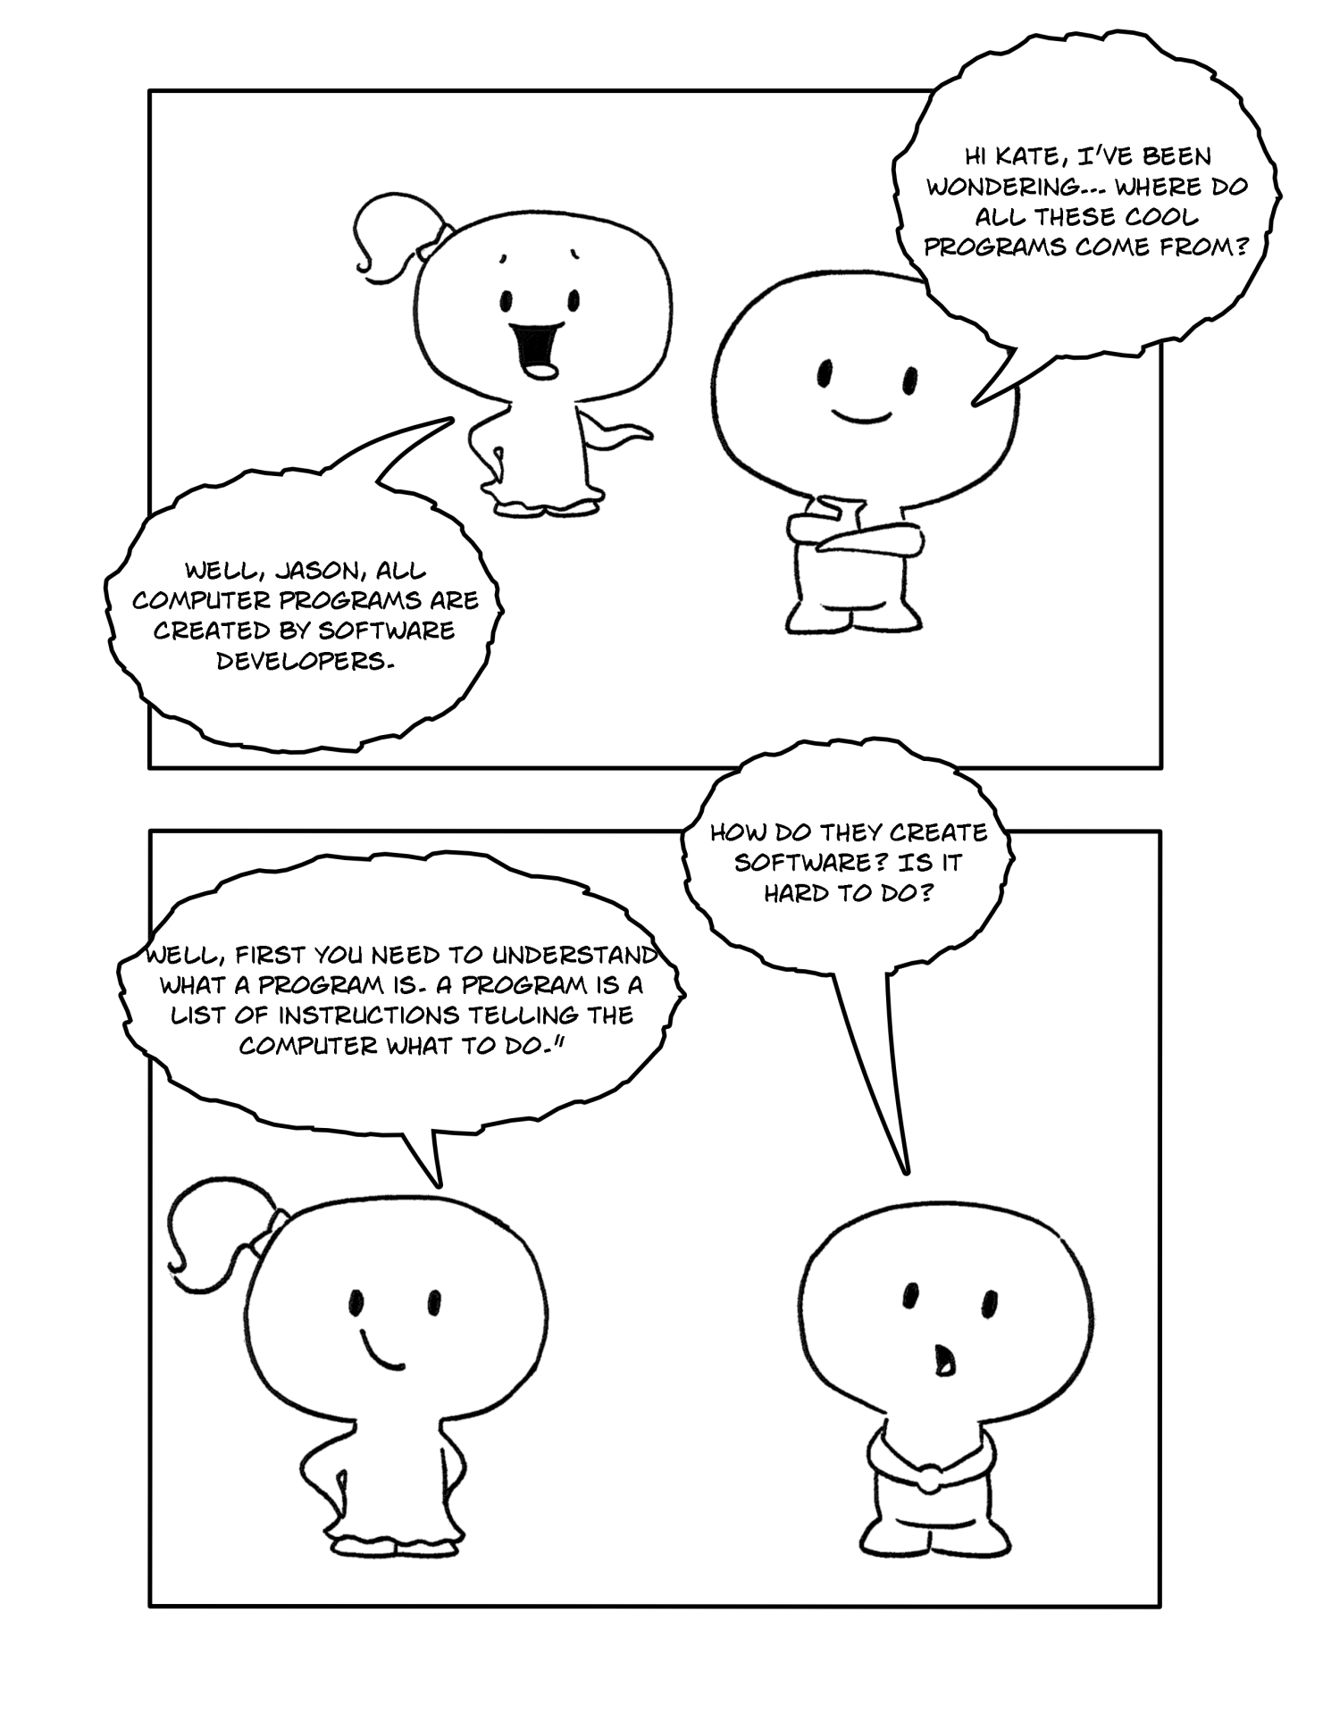
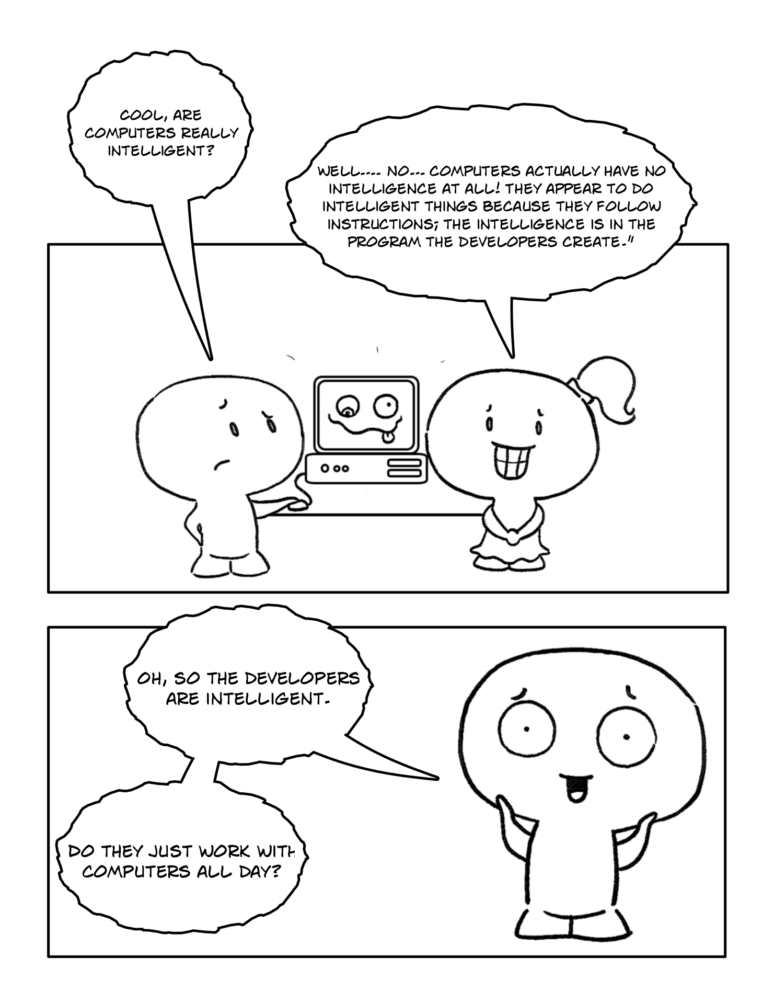
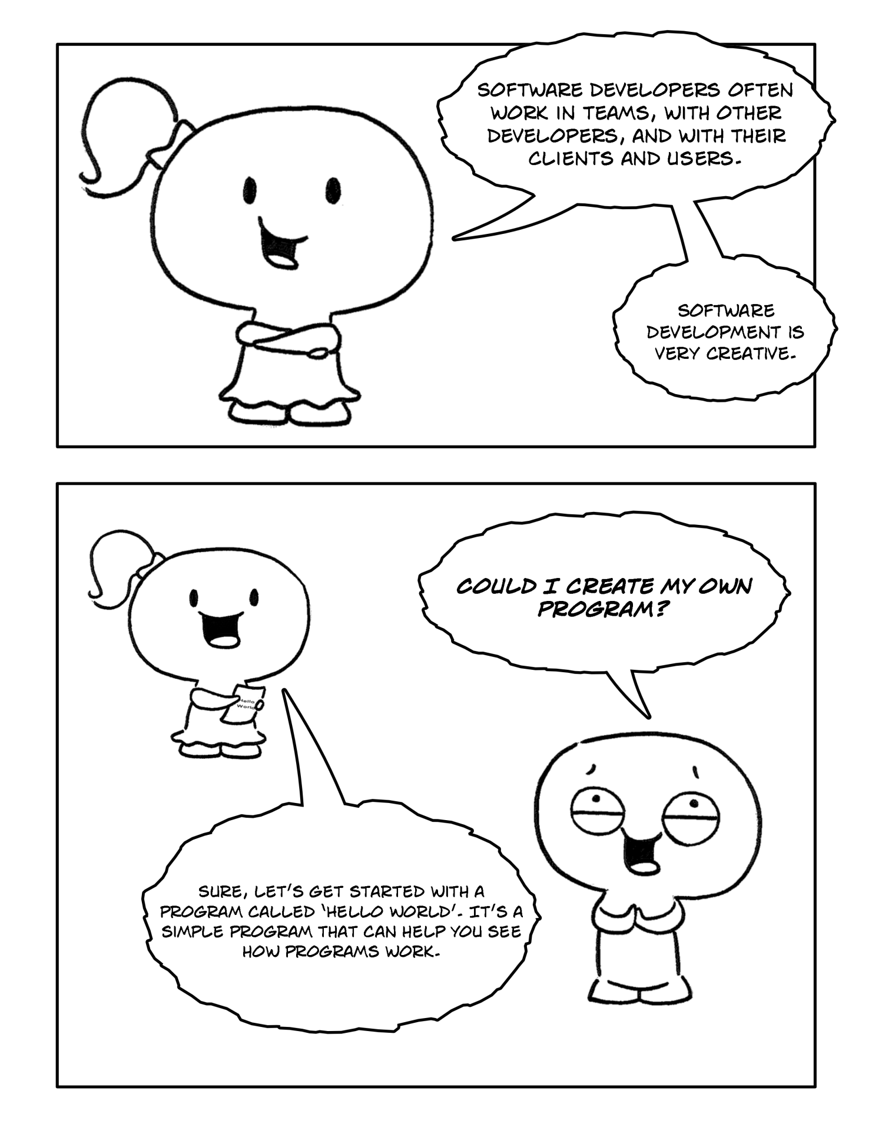

Part 1

"Hello World" program is the program to start learning any programming languages from. This is the simple program which prints the "Hello World!" message on the screen. It is used to explain the computer principles for a particular programming language. It also helps to check whether the Swingame project set up correctly. Follow these steps to get a "Hello World" program working with SwinGame.

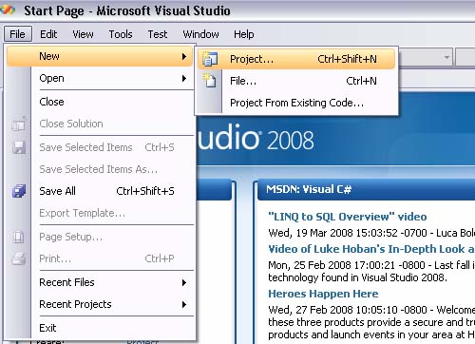
- Open Visual Studio, and click File > New > Project. As showed in Figure 1.
Figure 1
Figure 1
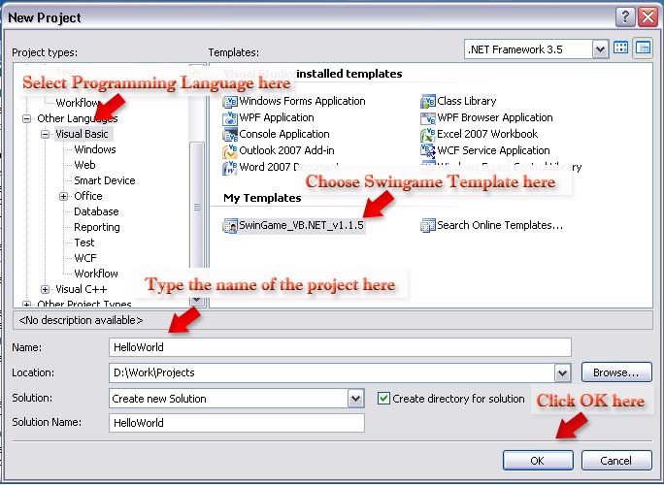
- Select the Visual Basic/Basic Language and click the SwinGame VB.NET Project Template. Name new project as “HelloWorld”. Click OK. The process is showed in Figure 2.
Figure 2

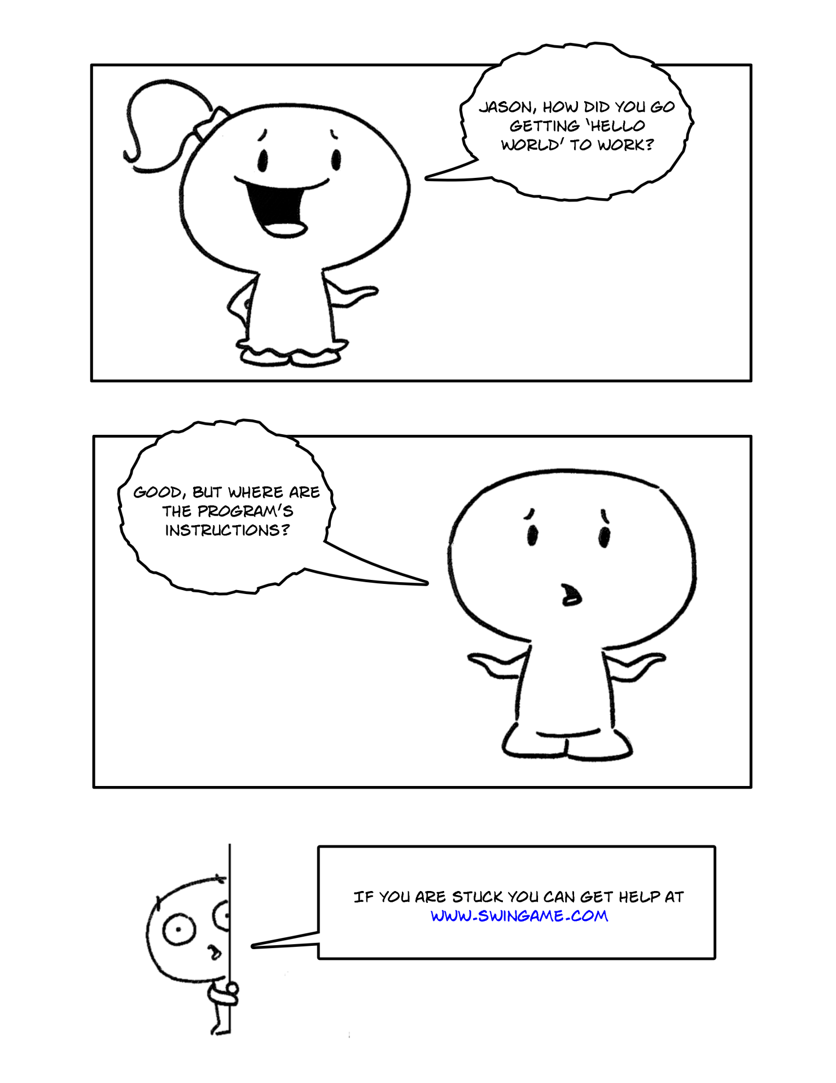

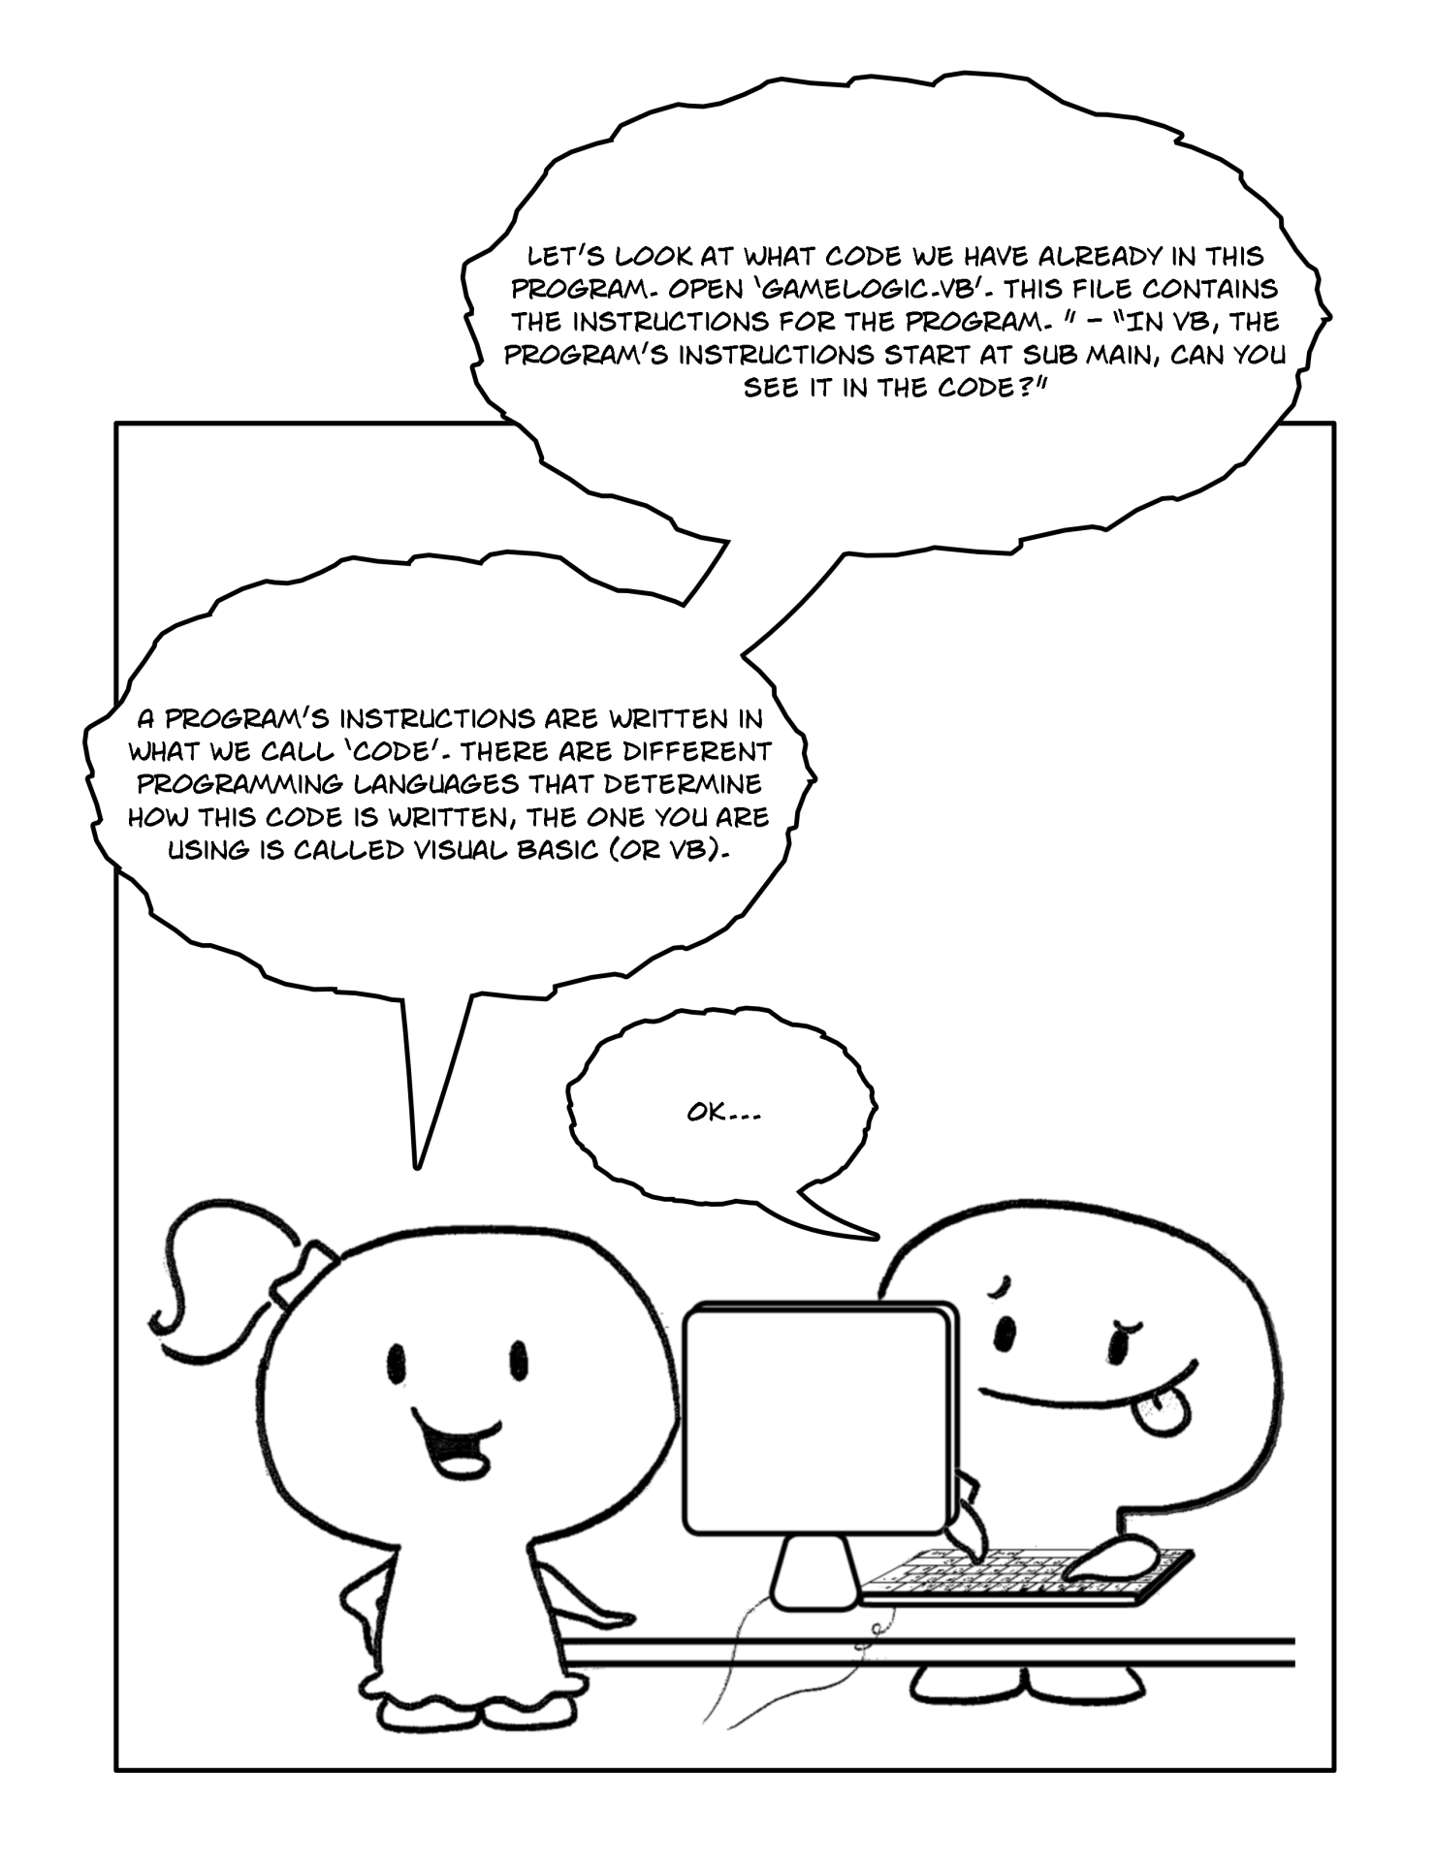

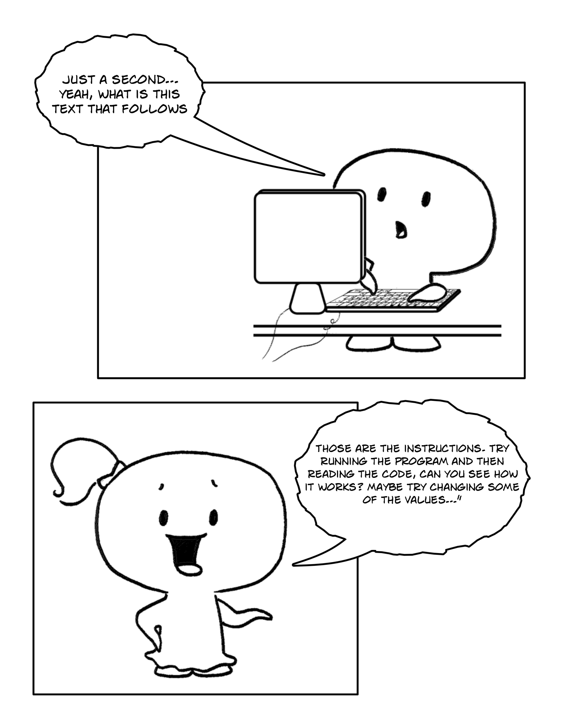

Part 2

In the Solution Explorer on the right hand side of the screen double click on "GameLogic", as showed in Figure 3. You should be presented with the following code:
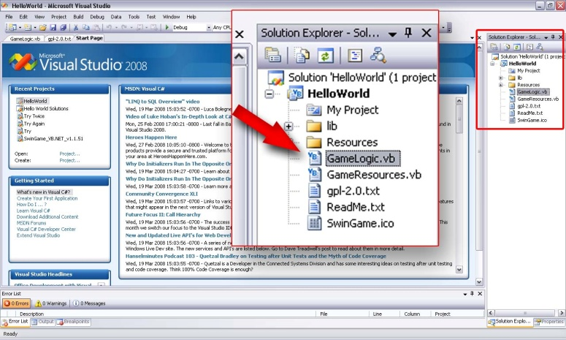
Code to be showed:
Figure 3

Module GameLogic
Public Sub Main()
'Opens a new Graphics Window
Core.OpenGraphicsWindow("Game", 800, 600)

'Open Audio Device
Audio.OpenAudio()

'Load Resources
LoadResources()

'Game Loop
Do
'Clears the Screen to Black
SwinGame.Graphics.ClearScreen()

'Draws red rectangle
Graphics.FillRectangle(Color.Red, 20, 150, 500, 50)

'Draws text "Hello World"
Text.DrawText("Hello World!", Color.Aqua, GameFont("ArialLarge"), 50, 50)

'Refreshes the Screen and Processes Input Events
Core.RefreshScreen()
Core.ProcessEvents()

Loop Until SwinGame.Core.WindowCloseRequested() = True

'Free Resources and Close Audio, to end the program.
FreeResources()
Audio.CloseAudio()

End Sub

End Module
The purpose of this code is to create a starting point for your project. If you press the "StartDebugging" button at the top of the screen (looks like a green arrow , F5 works too) you will see what it does. Have a look, and then close the window.

You can basically read what it is doing 'comments are in green with a single parenthesis at the start like this sentence. Every line in the program is doing something, but the most important are subs (i.e. Public Sub Main()... End Sub) and sub calls (i.e. Graphics.FillRectangle(rectangle color, Xpos, Ypos, Width, Height) or Text.DrawText("Text To Draw", Color, GameFont("FontName"), Xpos, Ypos)).

The Game Loop is a piece of code that is repeating to execute until the game window is closed. It is the actual "working" part of your game - it draws elements on the screen and provides the main functionality of the game. In our case, the game loop starts from Do keyword followed by some code to execute continuously and ends Loop Until SwinGame.Core.WindowCloseRequested() = True, that tells the program to stop executing of the code when the window is closed.
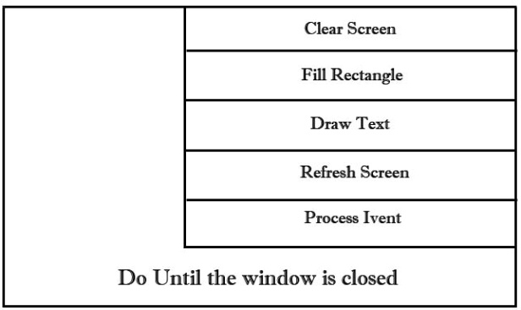
Do loop in VB.NET keeps executing statements while or until the condition is true. It has to be executed at least once, because the test occurs at the end of the loop. Here is Nassi-Shneiderman (N-S) Diagram for the game loop:
Figure 4. Game Loop

Exercises

Exercise1: Reading the code
Answer the following questions:

- Which line does contain the code that tells a computer to draw text on the screen?
- Which line does contain the code that tell a computer to draw a rectangle on the screen?
- Where (line number) does the game loop starts and ends?

NOTE: If there are no line numbers on the left side of the window, add them manually:

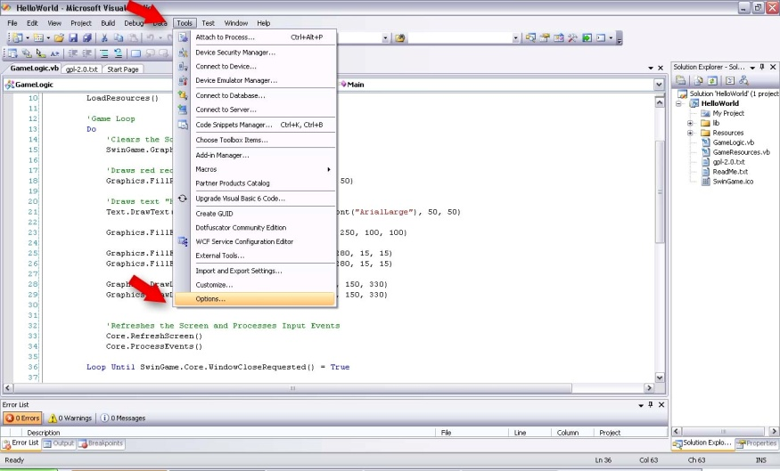
- Go to tools -> Options (Figure 5)
Figure 5

- Choose Text Editor -> All Languages -> General
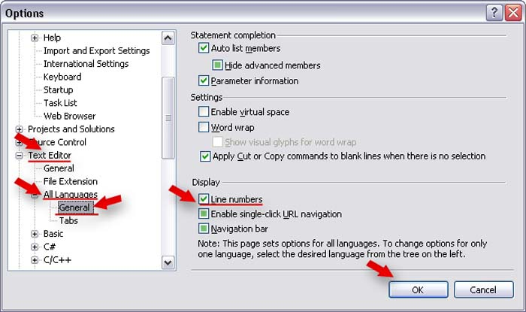
- Check Display Section -> Line Numbers (Figure 6)
Figure 6

Exercise 2: Changing the text

Make the following changes in your Hello World program.

- Change the text "Hello World!" to any other text to "Hello Your Name!"

Hints: When mouse is over the sub call (i.e. LoadResources()), the pop up window will appear which contains the list of parameters that this function takes and their order along with function description.

Exercise 3: Changing the color.

NOTE: Spelling is important. In this case, you MUST use American version - COLOR, not Colour. Otherwise, it will produce an error message and prevent your program from executing.

- Change the color of the text to Color.GreenYellow.

Hints: When you type Color. the list of possible colors will appear.

- Change the color of the rectangle to Color.Blue.
- Change the background color to Color.LightBlue.

NOTE: The ClearScreen() sub clears the screen to black color by default. To customize the background color, simply type "Color." followed by color name (Swingame.Graphics.ClearScreen(Color.LightBlue).

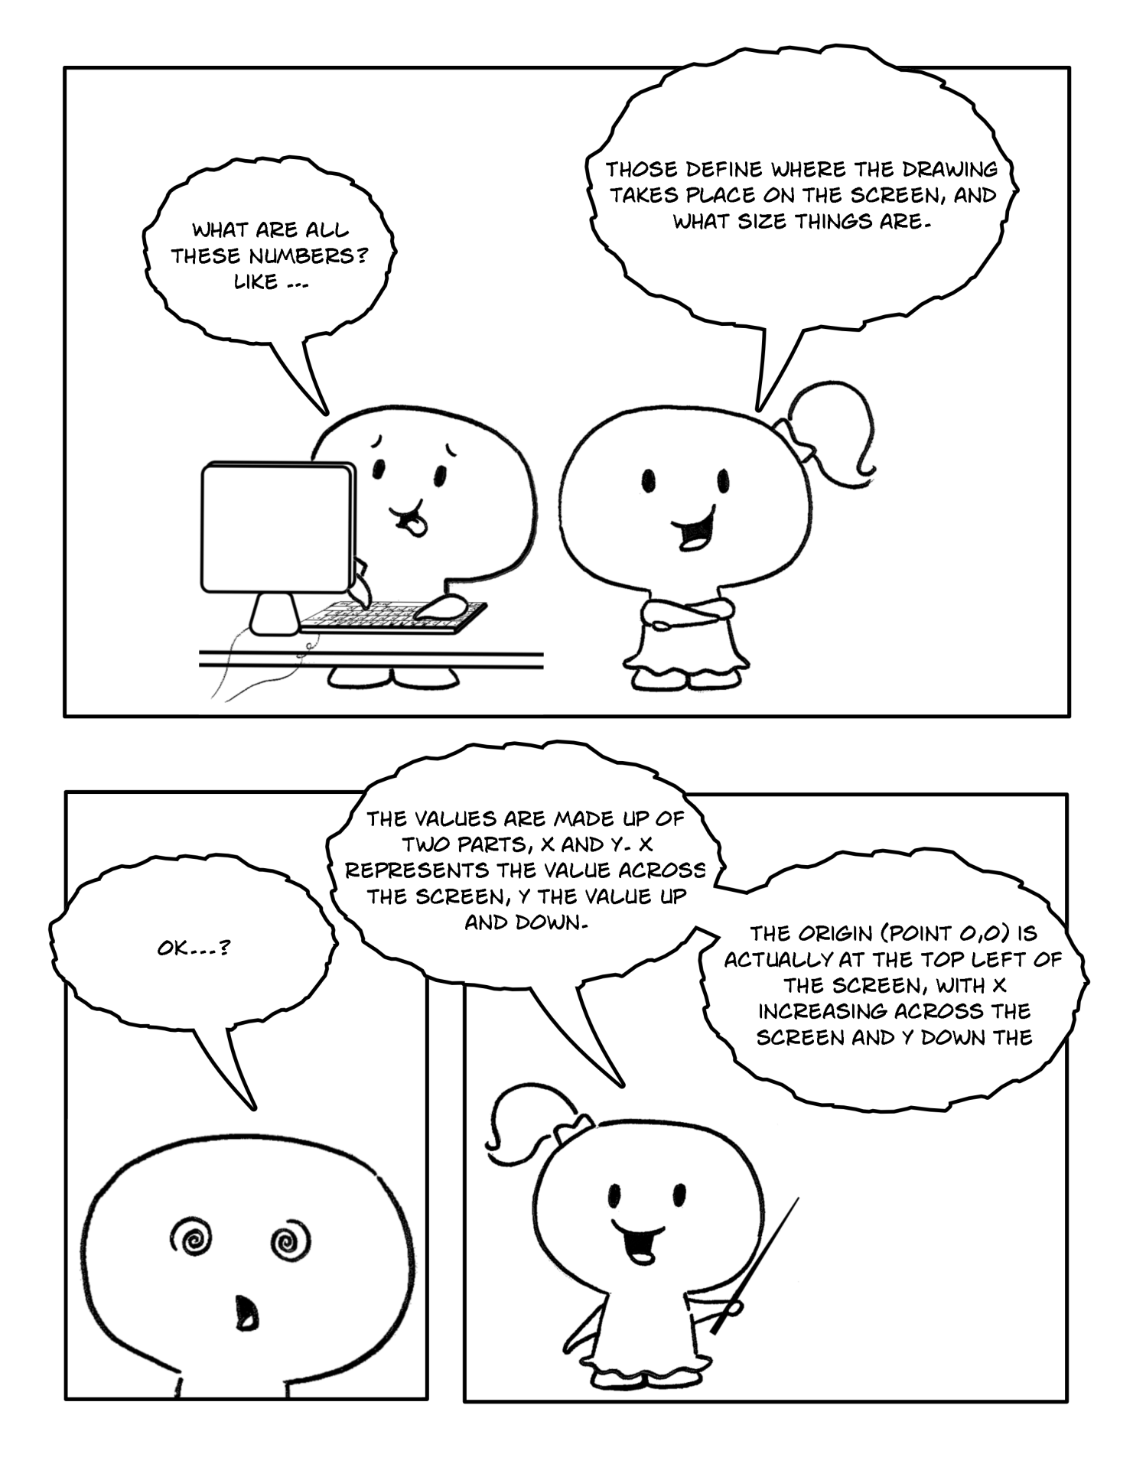

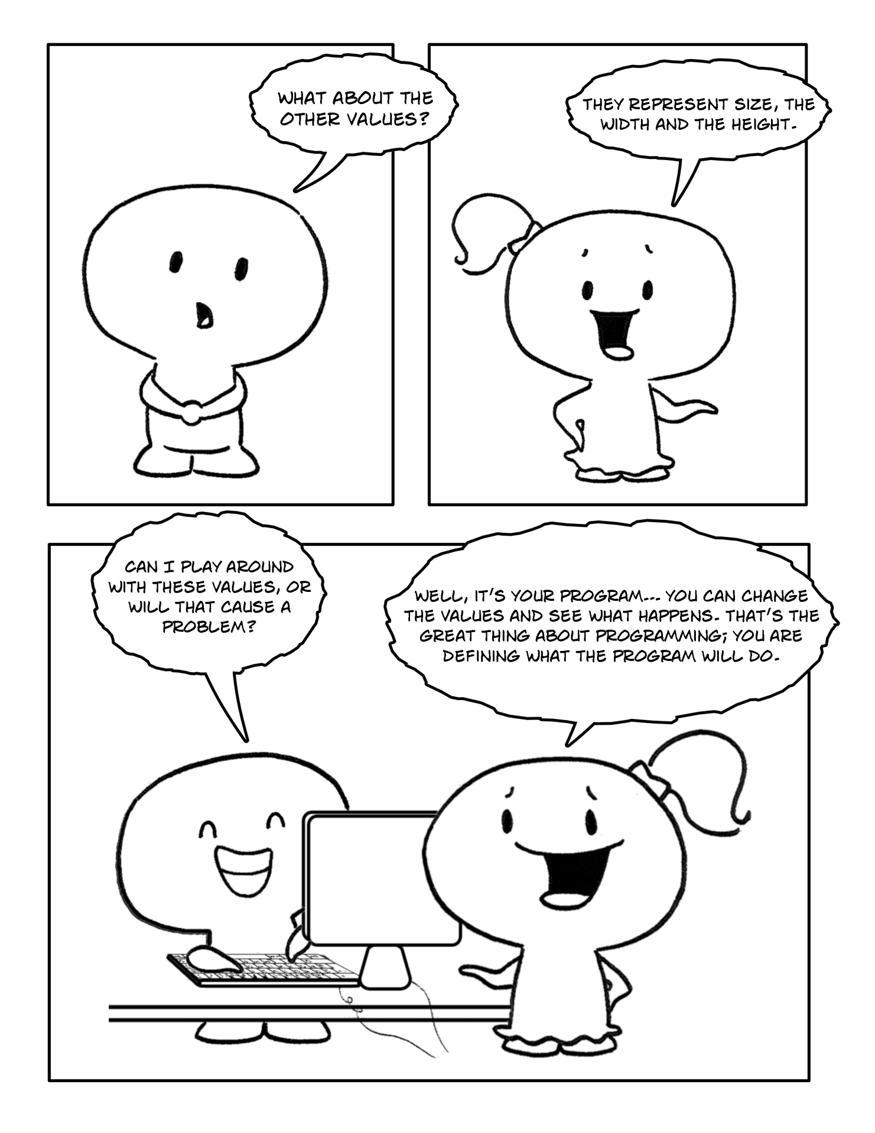

Part 3

Exercises
Exercise 1: Locations on the screen

Draw the following shapes and text onto your worksheet.

- On your worksheet, draw a rectangle with coordinates X = 15 and Y = 5 by hand.
- Draw the text “Hello Your Name” at X = 5, Y = 20.

Hints: The location of each element is determined by its X and Y coordinates. X and Y, in this case, are coordinates of the top left corner of each element as showed in Figure 7.
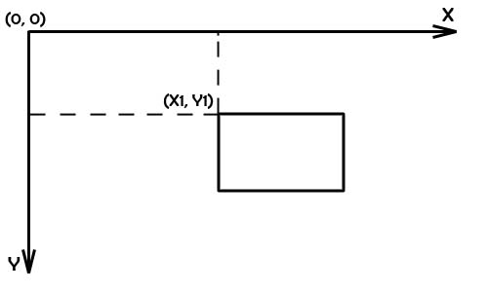
Figure 7. Coordinates
Exercise 2: Changing drawing locations

Make the following changes to your Hello World program.

- Change the location of the text; put it in the middle of the screen.
- Change the location of the rectangle; put it under the text.

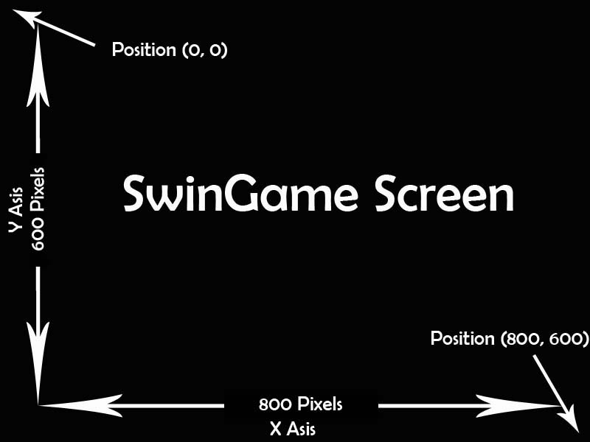
NOTE: The size of SwinGame screen is 800 pixels wide (X Asis) and 600 pixels tall (Y Asis) (Figure 8).
Figure 8

Exercise 3: Size of an element
Draw the following shapes and text onto your worksheet.

- Draw a rectangle with width = 5, height = 10 by hand.
- Draw a rectangle with width = 10, height = 5 by hand.

Exercise 4: Draw an element with the new size.

Make the following changes to your Hello World program.

- Change the size of the rectangle to width = 630 and height = 20.

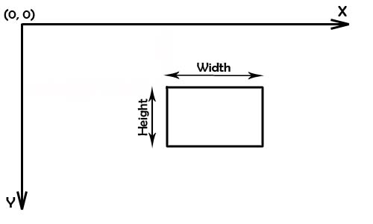
Hints: The size of any element, such as a rectangle or a circle, is declared by using width and height parameters (Figure 9).
Figure 9. Size

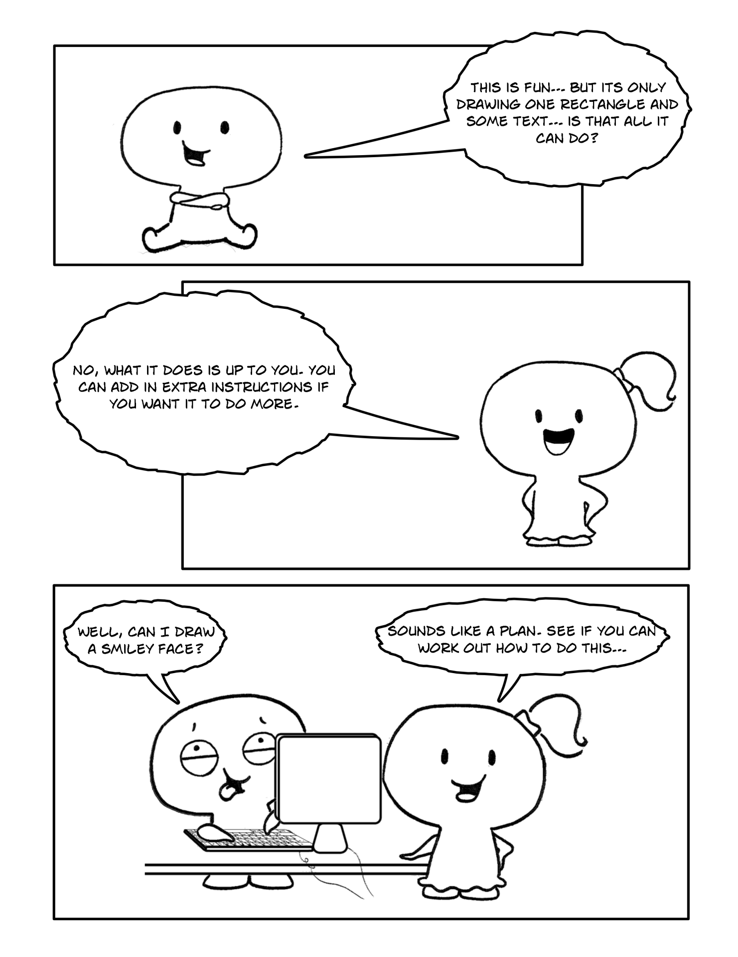

Extra Exercise:

Draw Smiley face on the screen:

- Draw a yellow circle on the screen – “face”. Use
Graphics.FillEllipseOnScreen(Color, Xpos, Ypos, Width, Heigh).
For example, Graphics.FillEllipseOnScreen(Color.Yellow, 100, 250, 100, 100)
- Draw the eyes – two black circles inside the yellow circle. Use the same sub call to draw, i.e.:
Graphics.FillEllipseOnScreen(Color.Black, 125, 280, 15, 15)
Graphics.FillEllipseOnScreen(Color.Black, 160, 280, 15, 15)
- Draw the “smile” on the screen.
Tell the computer to draw two lines which are connected at the bottom, inside the yellow circle. To do so, use Graphics.DrawLineOnScreen(Color, XPosStart, YPosStart, XPosEnd, YPosEnd, i.e.:
Graphics.DrawLineOnScreen(Color.Black, 130, 310, 150, 330)
Graphics.DrawLineOnScreen(Color.Black, 170, 310, 150, 330)

NOTE: Because drawing arcs is here is no arc line in SwinGame, “smile” will be made by two lines.
IMPORTANT!!!

Please, save exercises for each chapter in a folder named as “Chapter X”, where X is the number of the chapter.

